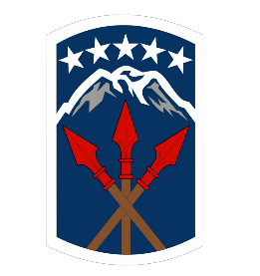
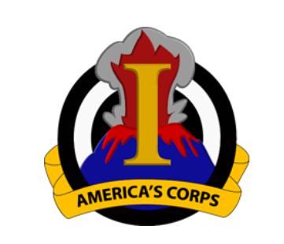

Soldier & Family Readiness Group (SFRG): The Nitty Gritty

What is an SFRG?
- An official command-sponsored organization of Family members, volunteers and Soldiers belonging to a unit, that together provides an avenue of support and assistance.
- SFRGs act as a conduit of information and a communication line between the Soldiers chain of command and the Families and between our Joint Base Lewis-McChord community and the Families.

Why are SFRGs important? They can serve as a mighty combat multiplier in your unit. Families should recognize they are an integral part of your winning combat team, playing a pivotal role helping their Soldier be the best warrior. A responsive, enthusiastic, and professional Soldier & Family Readiness Group can help Families recognize this and be a firm foundation of support for their Soldier, allowing the Soldier to focus at work and deployed.

What’s Important ? LTG George, I CORPS Commanding General has three top SFRG priorities, called WAR roles. Your job is to set up sustainable systems and help your volunteers help you consistently do them.

- Welcome new Families and Soldiers because first impressions matter
What tool will you use to track new Families?
What system will you create to ensure this tool is used?
Who will record this data on the SFRG rosters?
How will you get this information to the SFRG Leader?
Who will check to be sure new Families were welcomed?
- Accurate Contact Rosters (great information is only effective if Families get it!)
Spouse Preference Form and DD 93 cross check
How will you check roster accuracy?
How often will you check it?
- Resource referral and reliable unit & community information
Families should expect a three-month look-ahead calendar
Share the post and your unit website so Families can inform themselves.
The SFRG should offer confidential referral to agencies that can help if a Family needs help.

SFRG is a Team Sport! Here’s Some Help for You:
Your Battalion Command Family Readiness Representative (CFRR): In that position to support you and your unit! Ask them:
What’s the Battalion SFRG Calendar of events look like for the next quarter?
How can I recognize my volunteers?
Do you have the notes from the last monthly JBLM Community Information Exchange? The quarterly Brigade Steering Meeting?

Your Brigade CFRR- They get regular information updates from the Division CFRR that include resource reminders, events and opportunities, best practices and sample systems and products to help ensure WAR roles are successfully realized. Ask about these things!

The Division CFRR- Access across post to resources and information to empower Families. Point of Contact: 1LT Jaime Bass
Email address: jaime.t.bass.mil@mail.mil
Office number: 253-966-1236
Cell number: 757-955-3093

The I CORPS CFRR-Serve as the primary liaison between I CORPS and subordinate CFRRs.
Point of contact: CPT Zachary May
Email address: zachary.t.may.mil@mail.mil
Office number: 253-477-1584
Cell number: 253-355-9618

Your Volunteers- Ask their opinions and input! They are your Family matter experts. Share your vision and intent with them and ensure your communication lines are open for them.

The Joint Base Lewis-McChord website- Familiarize yourself with the UPCOMING EVENTS, the JBLM FACEBOOK, the TOP LINK. Look at this site regularly and encourage your Families to do the same.

Monthly Garrison Community Update- An hour meeting the 1st Wednesday (2nd Wednesday of the month due to a holiday) of each month, 0930 locations alternate between JBLM Main & McCord to share resources, events and opportunities happening in the next few months. Everyone, including Families welcome!

