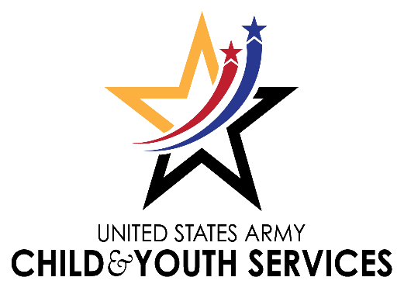

Fall Soccer 2022
And Bumblebee Soccer

Dear Parents: August 29, 2022

The Child & Youth Services (CYS) Sports & Fitness staff welcomes you to the 2022 Spring Soccer Program. This letter will answer some general questions you may have about the program.

CYS Sports hosts a RECREATION LEAGUE that is inclusive of all youth who want to learn the fundamentals of the game and to have fun.

Any further questions may be addressed to the Sports & Fitness Director or our amazing sports staff. We encourage parents to become involved in our recreational sports program by being a coach, team parent, or offering assistance to staff on game days.
Ages & eligibility: A child must be 3 years old and no older than 15 years of age by 10 September ‘22 in order to play. The team ages will be divided as follows: 3 to 4, 5 to 6, 7 to 8, 9 to 10, and 11 to 15.
Current sports physical: A Sport physical with the doctor’s medical stamp is good for 12 months. To keep your child’s sports physical current through the end of the sport season, you will have 10 days from the date of expiration to provide parent central with a new sports physical. The end of soccer season will be on 8 October ‘22 for Bumblebee soccer (3-4 year olds) and 15 October ‘22 for 5 years and up. Parent Central will accept a copy of the medical form you may have obtained for school, provided it has the required documentation on it and you attach it to the CYS Health Assessment/Sports Physical Form and fill out the front and sign the back.
PARENT MEETING:
Your coaches will be conducting your parent meeting at your first practice.

PRACTICES: The days and times are 2 times per week between 1700 and 2000. CYS Sports is limited to three hours per week including practices and games.

**During practice and games, the parents/guardians are responsible for the supervision of the siblings that are not participating in the sporting activity. **Pets are not allowed on any CYS or Adult sports fields on JBLM. **No smoking or vaping within 50 feet of the fenced area for the field. **

Games: Games will be played Saturday’s beginning on 10 September ‘22 and will continue through 8 October ‘22 for Bumblebee Soccer and 15 October ‘22 for ages 5 – 15 years. Your child’s coach will have the game schedules by the 2nd week of practices.

Snacks: A list of acceptable snacks will be provided to your coach. Please adhere to the suggestions as we are trying to encourage healthy habits at a young age. Snacks should be nutritious in content. Please dispose of snacks in designated trash cans located near the bleachers.

Fees: Your registration fee is regulated by Department of the Army (DA). This fee covers medals, certificates, and a team photo for all players posing in the photo. This fee also helps offset costs for field maintenance, labor, and official’s fees.

Volunteers: In order to coach or assist a team, a background clearance and a coach’s certification training is mandatory. Discounts for volunteer head coaches and assistant coaches participating in any CYS sport in any given season are authorized, once a background check is cleared (2-6 weeks from time you turn in) and NAYS & CYS training are completed. Please contact the CYS Sports Office if you are interested at (253) 967-2405.

UNIFORMS: If we are able to get sponsors, then our athletes will be able to keep their t-shirts or jersey. Shin Guards are mandatory and cleats are recommended.

Appropriate Conduct: Parents and coaches are reminded that comments should be kept to a minimum and foul language will NOT be tolerated at the games. Adherence to the Parents Code of Ethics will be enforced. Incidents of inappropriate behavior will be reviewed and corrective action will be taken. Remember to role model Pursuing Victory with Honor – Character Counts both on and off the field.

For more parent information, please go to the following website:
https://jblm.armymwr.com/programs/youth-sports

The CYS Sports & Fitness team thank you in advance for your support. (253) 967-2405

CYNTHIA A. WILLIAMS-PATNOE
CYS Sports & Fitness Director

